**Software Design Description(SDD)**

for

Web-based Assignment Submission System

**Author:** Uttam Yadav

**Table of Contents**

1. **Introduction**
2. System Design Description
   1. Use cases
      1. Teacher-Administrator
      2. Student

**Terminologies used**

**OSS - Online Submission System**

**1.1.1 The Client Organization**

St. Francis Higher Secondary School is an educational institute located in Pithampur Dist. Dhar Madhya Pradesh. Nearly, 3000 students are studying here from Class Nursery to Class 12th . Previously all the assignments are submitted manually by the students but in the wake of COVID-19 all the educational work has been setup to online and all students submit their assignments on WhatsApp group created by their respective subject teachers.

**1.1.2 Purpose, Scope, and Objectives**

The purpose of the project is to analyse the requirement of, design, implement, and maintain the software for both the administrator and users.

This web-based app is intended to solve the client’s tedious job of assignment submission. This system will provide a user interface to both the students and teachers at the client’s organization.

This system will keep track of all the assignments and as well as assigned and submission date and is intended to generate the report of students who submitted the assignments in Excel file.

All the activities directly related to the purpose are considered to be in scope. All activities that are not directly related are considered out of the scope.

The objectives of the project are as follows:

* Complete the project by the project due date.
* Provide all the deliverables to the client by the project due date.
* Fulfil all the requirements, as in the SRS, of the software deliverable.

**System Design Description**

This report describes the system design of OSS and the topics in this chapter are Use-case diagrams, class diagram, sequence diagrams and data base design.

**1.1 Use case diagram for OSS**

**“**Its purpose is to present a graphical overview of the functionality provided by a systemin terms of actors, their goals (represented as use cases), and any dependencies between those use cases**”** 3.

**1.1.1 Teacher- Administrator**

Teacher can add, delete or update students; courses, assignments, and uploading Nant script file to testing all assignments.

**Description**

This package contains all the functionalities that an administrator can do.

**Use Cases**

1. Login to OS

O Add, delete and update students.

**O** Add, delete and update courses.

**o** Add, delete and update assignments.

**o** Registration courses for students.

**o** Uploading Ant/Nant script files.

**o** Running the Ant/Nant script files for testing the assignments.

1. Generate Report for students.

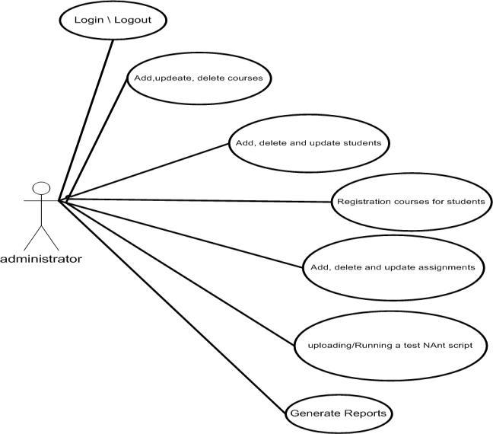

Figure: Use-case diagram for administrator

**1.2 Student**

Student can see the information about the assignment (description and instruction, start-time, end-time, motivation, how to download the assignment and upload it, type of work individually or as groups).

**Description**

This package contains all the functionalities that student can do.

**Use Cases**

o Login to OSS

**o** Update profile

**o** View the register courses **o** View the assignments

1. Uploading the solution of assignments.

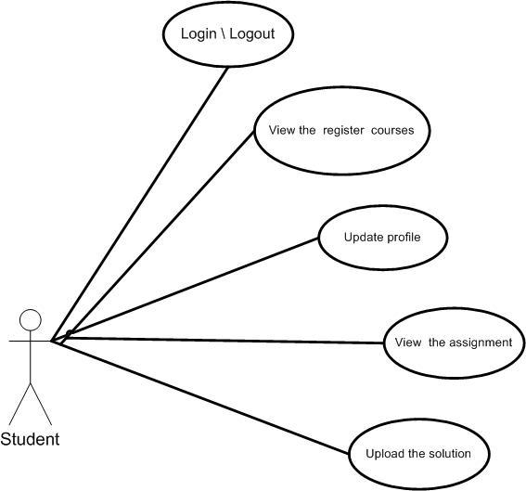

Figure: Use-case diagram for student